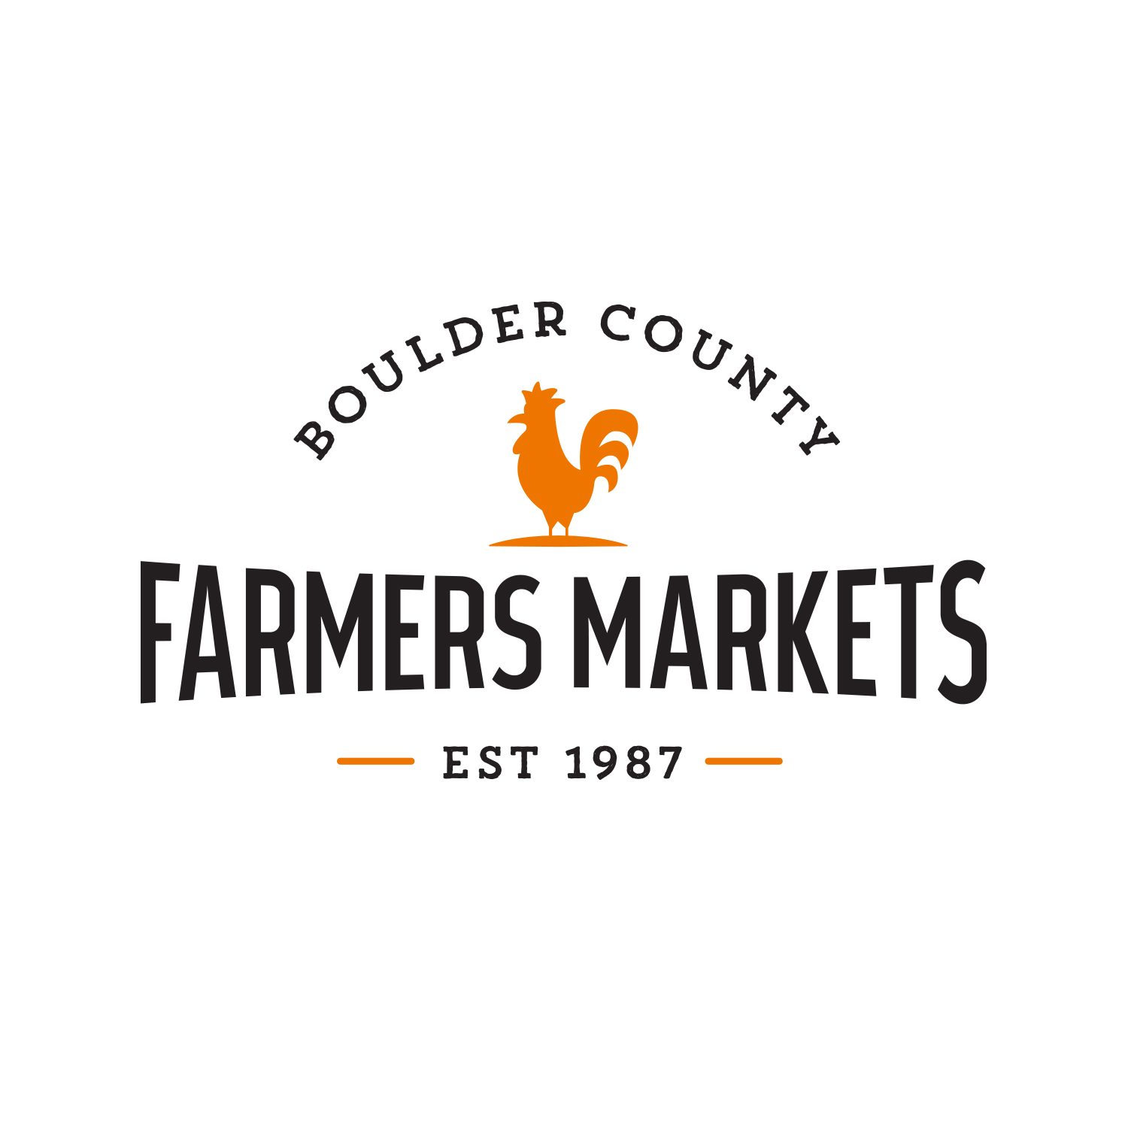
Boulder County Farmers’ Markets

WAIVER OF LIABILITY

The waiver of liability is to be read and agreed to by all persons volunteering with Boulder County Farmers’ Markets.

No one will be allowed to volunteer without a agreeing to the Waiver of Liability.

I understand that by volunteering with the Boulder County Farmers’ Markets I may be exposed to various risks of injury or harm. I understand and assume these risks and agree not to hold Boulder County Farmers’ Markets, its Board of Directors, employees, clients or vendors liable for any such injury or harm, or compensation for the same.

I also agree that I will not hold Boulder County Farmers’ Markets and its Board of Directors, employees, clients or vendors liable for any damage or injury to me or my property as a result of my volunteering at Boulder County Farmers’ Markets in Longmont, Boulder or at the BCFM Office. I agree to be responsible for my behavior and to indemnify and hold harmless Boulder County Farmers’ Markets, its Board of Directors, employees, clients or vendors for any damages or liabilities arising out of my activities as a volunteer.

I also grant full permission for my name, likeness and image, including photographs and video recordings that are taken of me while engaged as a volunteer, to be used by Boulder County Farmers’ Markets for promotional purposes.

